Lava Lamp

Subject:  Related Subjects: | Grade Level(s):  Length of Lesson: | Type: Inquiry / Design / Project  Keywords:

Lesson Overview
Use this section to describe at a high level what the lesson is. Should be no more than 3-4 lines.

Lesson Focus
What is the central question or phenomenon being investigated? What problem are they trying to solve?

Lesson Objective(s) | Students will learn about the chemical properties of oil and water and how that affects how they mix, by engaging in an experiment in which they will create a “lava lamp.”

Lesson Timing

5 minutes | Introduce the Lesson
30 minutes | ...

Materials | - Water  - A clear plastic bottle  - Vegetable oil  - Food coloring  - Alka-Seltzer (or other tablets that fizz)
Instructor Prep | - Step 1
Related Resources | - List related lessons/ppts etc available from USC or outside, trusted orgs

Lesson Plan

Introduction
The oil and water you added to the bottle separate from each other, with oil on top because it has a lower density than water. The molecules of water are packed very densely. This means if we take equal parts of water and oil, there will be more molecules of water than oil. This also means that water will always sink underneath the oil. They also cannot mix because water is polar (which means a molecule is positively charged at one end and negatively charged at the other) and oil is non-polar. Polar molecules only dissolve in polar solvents. Non-polar molecules only dissolve in nonpolar solvents. Like dissolves like.
The piece of Alka-Seltzer tablet you drop in after releases small bubbles of carbon dioxide gas that rise to the top. Alka-Seltzer fizzes because it contains citric acid and baking soda (sodium bicarbonate). The two react with water to form sodium citrate and carbon dioxide gas (those are the bubbles that go to the top of the bottle.) The carbon dioxide is much less dense than both the water and oil which is why it quickly floats to the top of the bottle.

Procedure
- Pour water into the plastic bottle until it is around one quarter full (you might want to use a funnel when filling the bottle so you don't spill anything).
- Pour in vegetable oil until the bottle is nearly full.
- Wait until the oil and water have separated.
- Add around a dozen drops of food coloring to the bottle (choose any color you like).
- Watch as the food coloring falls through the oil and mixes with the water.
- Cut an Alka-Seltzer tablet into smaller pieces (around 5 or 6) and drop one of them into the bottle, things should start getting a little crazy, just like a real lava lamp!
- When the bubbling stops, add another piece of Alka-Seltzer and enjoy the show!

Wrap-up
- True or false: Water is nonpolar
- What does it mean when something is polar mean?
- Why do the oil and water separate?
- Why does the oil sit on top of the water?

Lesson Background for Teachers

Suggested Real-World STEM Connections
Person of Color:
Lewis Howard Latimer was and African-American inventor engineer. He was born in 1848 in Chelsea, Massachusetts, to parents who escaped slavery. He improved the incandescent light bulb, which had already been invented by Thomas Edison, by inventing the carbon filament.
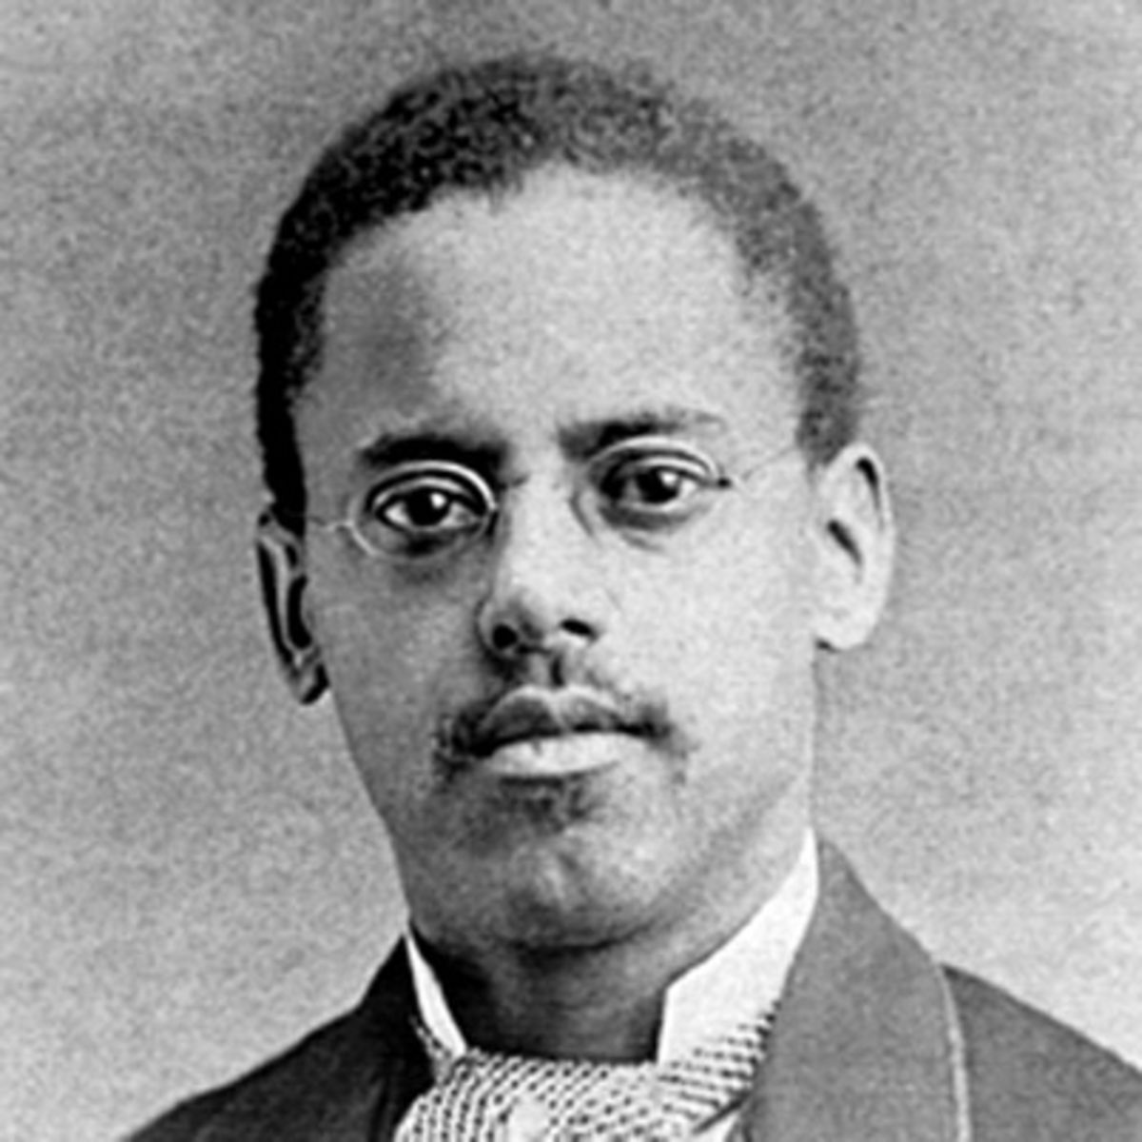

Lesson Variations and Options
Include descriptions of alternative methods or ways to present things.

Explanation
Describe the background concepts and explanations behind the lesson. This can be more in depth than a teacher/instructor would actually share with students.

Key Concepts and Vocabulary
- Word 1: Grade Appropriate Definition
- Word 2: Grade Appropriate Definition

Safety Notes
- Safety instruction

